

**MIDDLE EAST TECHNICAL UNIVERSITY**

**ELECTRICAL AND ELECTRONICS ENGINEERING DEPARTMENT**

**STATIC POWER CONVERSION I**

**HARDWARE PROJECT REPORT**

Ankara Instruments

Özgür DURDU-1823319

Muhammet Emin CİNALİOĞLU-2030427

Talgat BUZURKANOV-

Table of Contents

1. Introduction 3

2. The DC Motor Specifications 3

3. Topology Selection 4

4. Simulations 6

5. Component Selection 11

6. Test Results 15

6.1. Rectifier Test 15

6.2. Pulse Width Modulation using Arduino 16

6.3. R-Load Test of Buck Converter 17

6.4. RL-Load Test of Buck Converter 18

7. Thermal Design 20

8. Cost Analysis 21

9. Conclusions 22

1. Introduction

This report includes an AC to DC converter design and producing steps in order to derive a DC motor. There are several topology in order to drive a dc motor such as 1-phase thyristor rectifier, 3-phase thyristor rectifier, diode rectifier with buck converter etc. This report includes comparison between these topologies. Advantages and disadvantages were considered when comparing the topologies. Also you can see design process of selected topology in detail in this report. Moreover, this report includes some simulation and their results in order to prove the performance characteristics of the driver. In addition to this, there is a thermal design in order to keep the temperature of the devices in the safe range. Finally, you can see cost analyze of the final product in the report.

2. The DC Motor Specifications

You can see the DC motor and its specification in the Figure 1 and Figure 2 respectively and its parameters below.

The motor's parameters:

* Armature Winding: 28 Ω, 13.3 mH
* Series Winding: 65 mΩ, 260 uH
* Shunt Winding: 8.26 kΩ, 6.4 H
* Interpoles Winding: 0.8 Ω, 5.8 mH
* Inertia: TBA

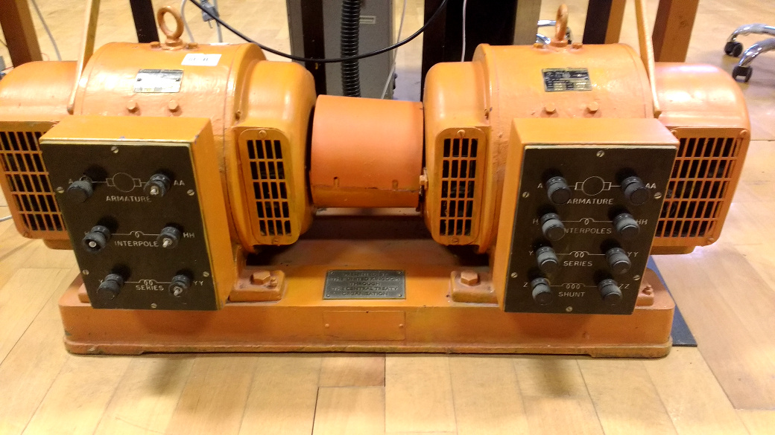

Figure 1: DC motor and generator set.

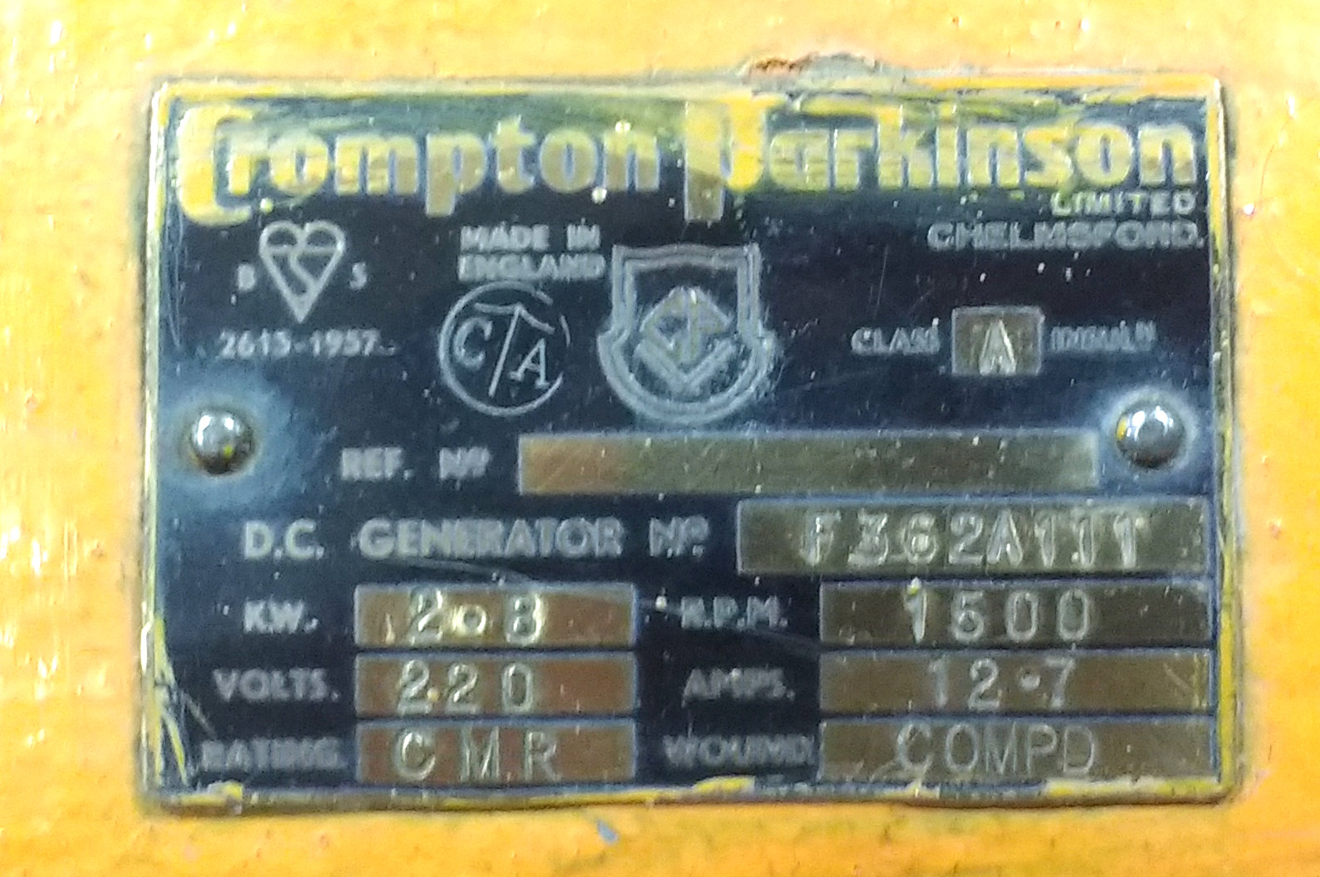

Figure 2: Motor template.

3. Topology Selection

We considered 3 different topology which are 3-phase thyristor rectifier, 1-phase thyristor rectifier and diode rectifier and buck converter. We compared advantages and this advantages of each. You can see advantages and disadvantages of each topology in the Table 1.

Table 1: Advantages and disadvantages of the topologies.

|  |  |  |
| --- | --- | --- |
| Topology | Advantages of the Topology | Disadvantages of the Topology |
| 3-Phase Thyristor Rectifier | * Low output ripple than one phase thyristor rectifier * Higher output voltages than one phase thyristor rectifier | * need more thyristor than one phase rectifier * Cost is higher than one Phase thyristor rectifier * inject large harmonics into the utility system * When output voltage is small, power factor and displacement power factor is very poor. * producing notches in the line voltage waveform |
| 1-Phase Thyristor Rectifier | * less thyristor than 3 phase thyristor rectifier * Control circuit more basic than 3 phase thyristor rectifier | * Output voltages less than 3 phase thyristor rectifier * inject large harmonics into the utility system * When output voltage is small, power factor and displacement power factor is very poor. * producing notches in the line voltage waveform * You must use large capacitor to obtain low output voltage ripple |
| Diode Rectifier and Buck Converter | * You can control the switching frequency to reduce output voltage ripple * small filtering component | * When Ls and Ld are small, the current İd and is are highly discontinuous and there are very poor power factor at the utility * need more passive elements |

As you can see in the Table 1 each topology has advantages and disadvantages. Firstly, we wanted to use small passive element in the output. Because of this we should have eliminated output voltage ripple as much as we can. So that, we eliminated the 1-phase thyristor rectifier even if 1-phase thyristor topology has less thyristor than 3-phase thyristor topology. After that, we wanted to use basic control unit in order to eliminate possible control circuit problem. Because of this we decided to use diode rectifier and buck converter topology even if it has more passive elements.

4. Simulations

Before starting hardware implementation, according to selected topology, some simulations were done. These results of simulations were taken from MATLAB Simulink.

Table 2

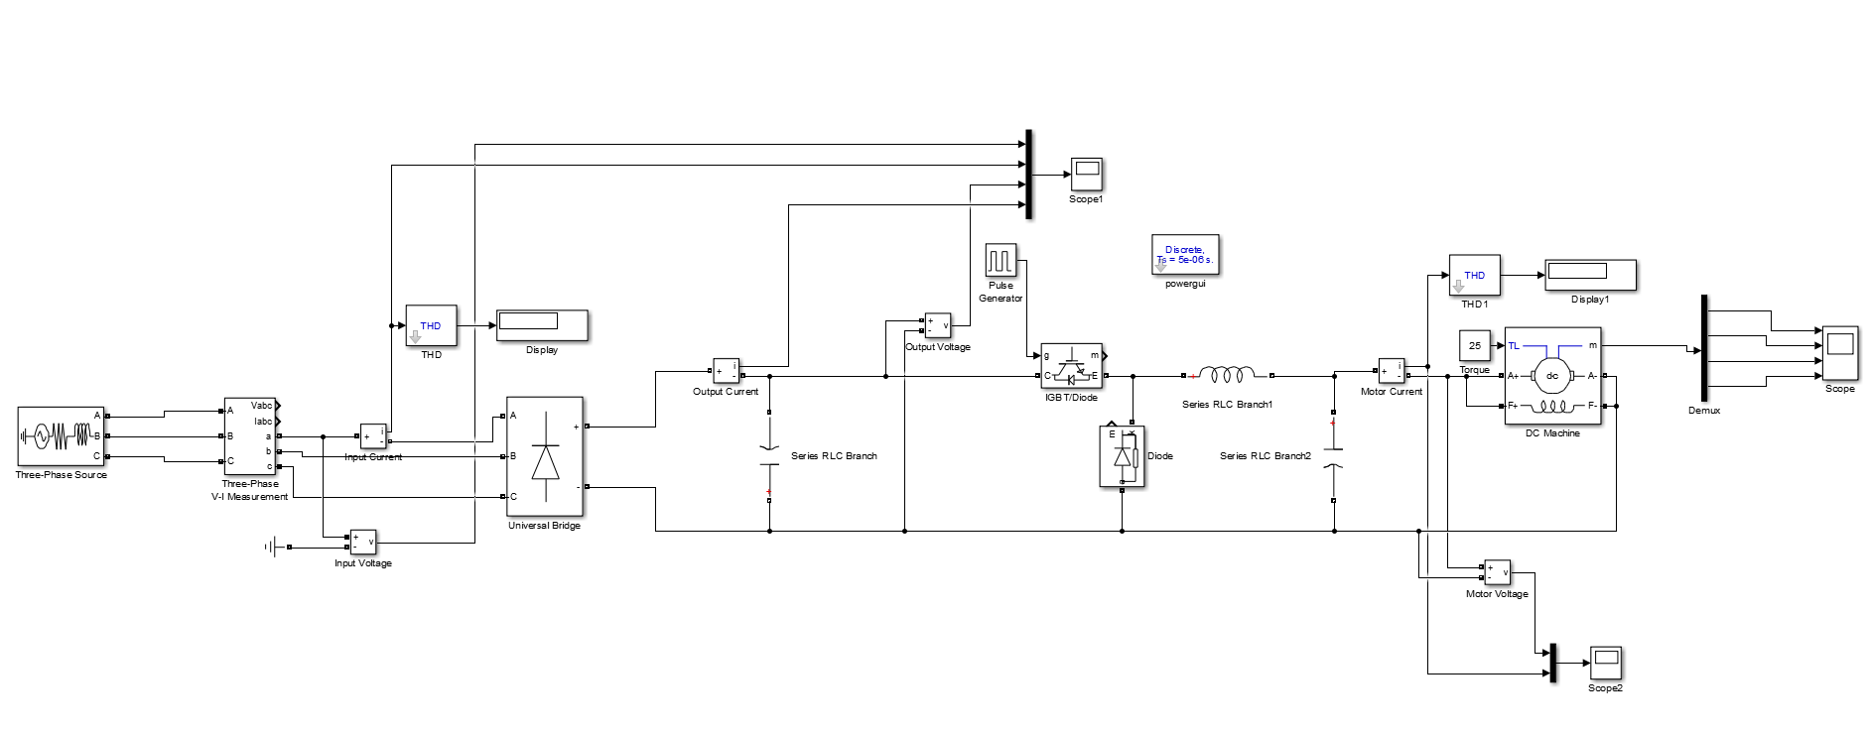

Figure 3: Design Schematic of the Selected Topology

In Figure 3, design schematic of the selected topology is given. Simulation results are taken from the output of the diode rectifier, output of the buck converter and the measurement pin of the DC motor. Also to analyze THD of the input current, input measurement is taken from the source side. Firstly, 85% duty cycle PWM signal is given the switching element and the measurements are observed.

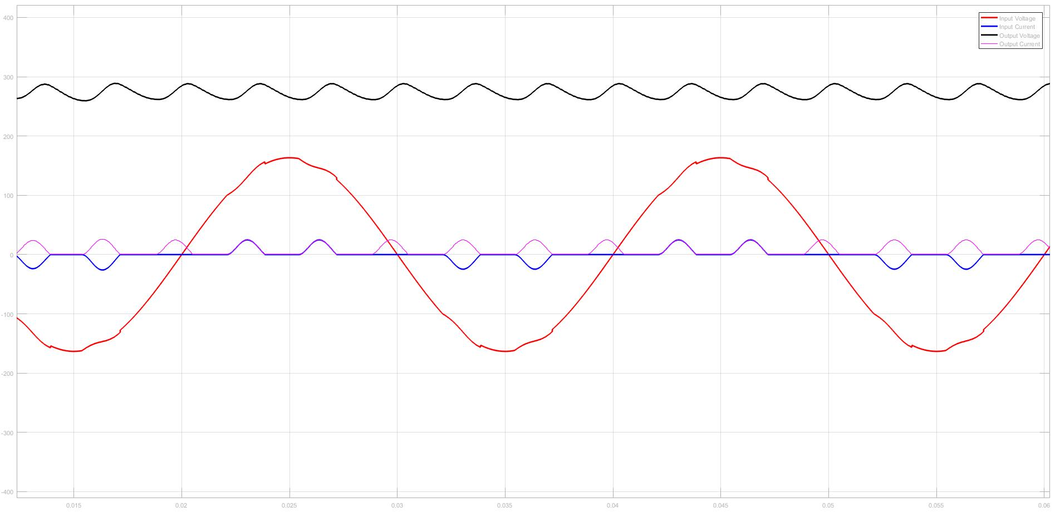

Figure 4: Input and Output Characteristic of the 3-Phase Diode Rectifier (85% Duty Cycle)

THD of the input current is equal to 126%.

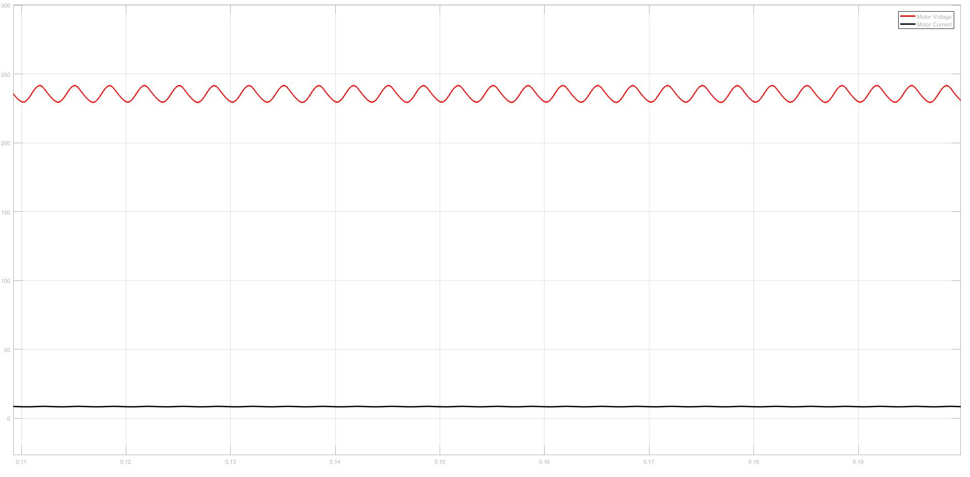

Figure 5: Output Characteristic of the Buck Converter (85% Duty Cycle)

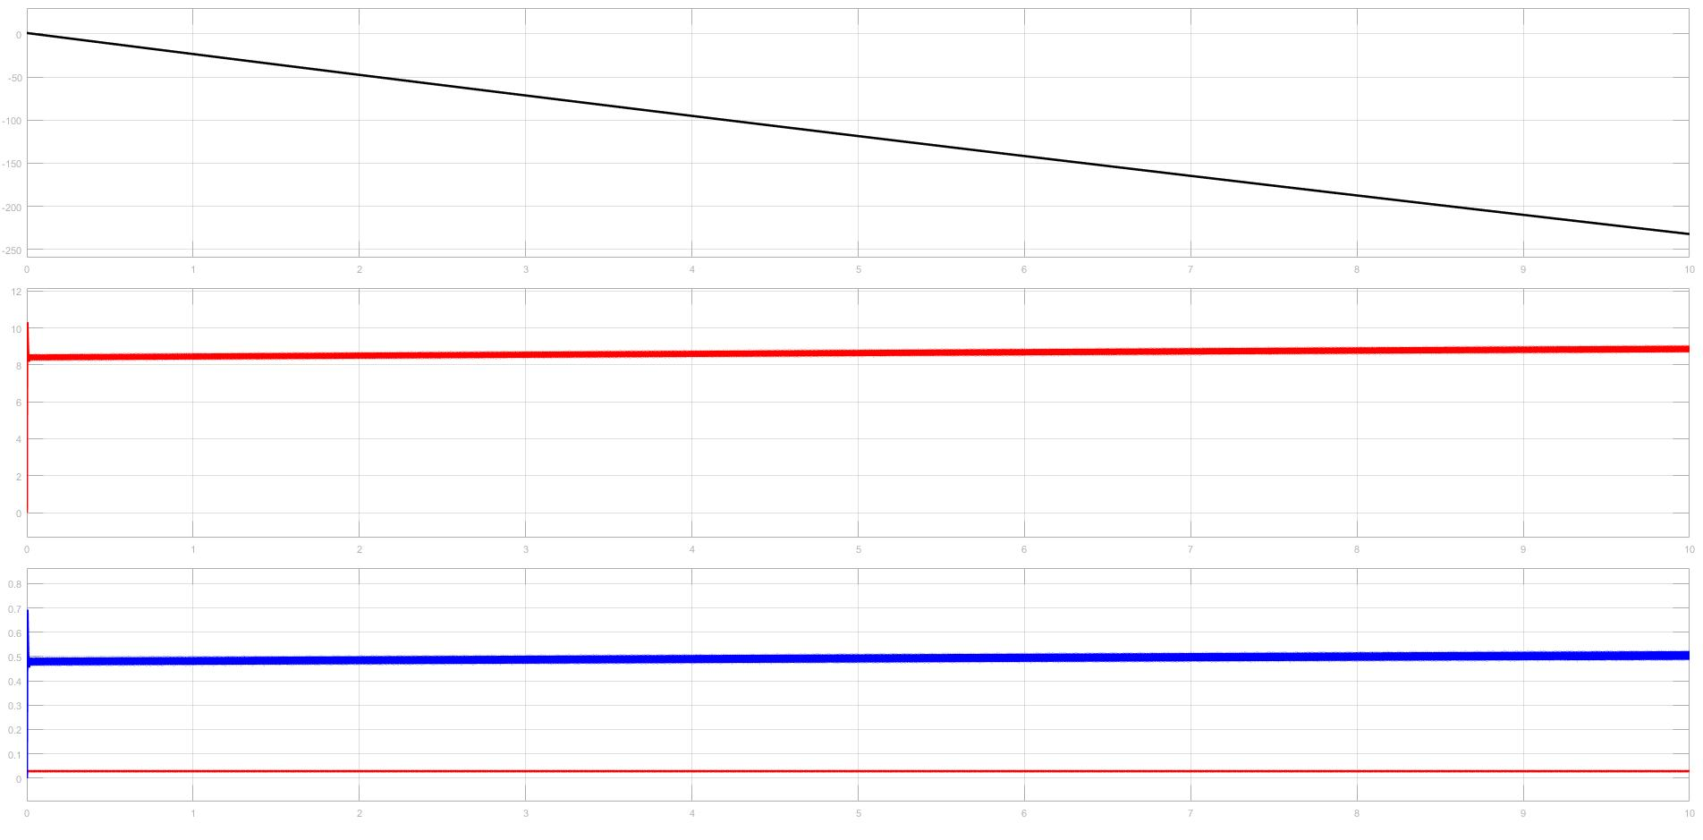

Figure 6: Motor Characteristic of the System (85% Duty Cycle)

Same procedure was applied for the 50% duty cycle and 15% duty cycle cases.

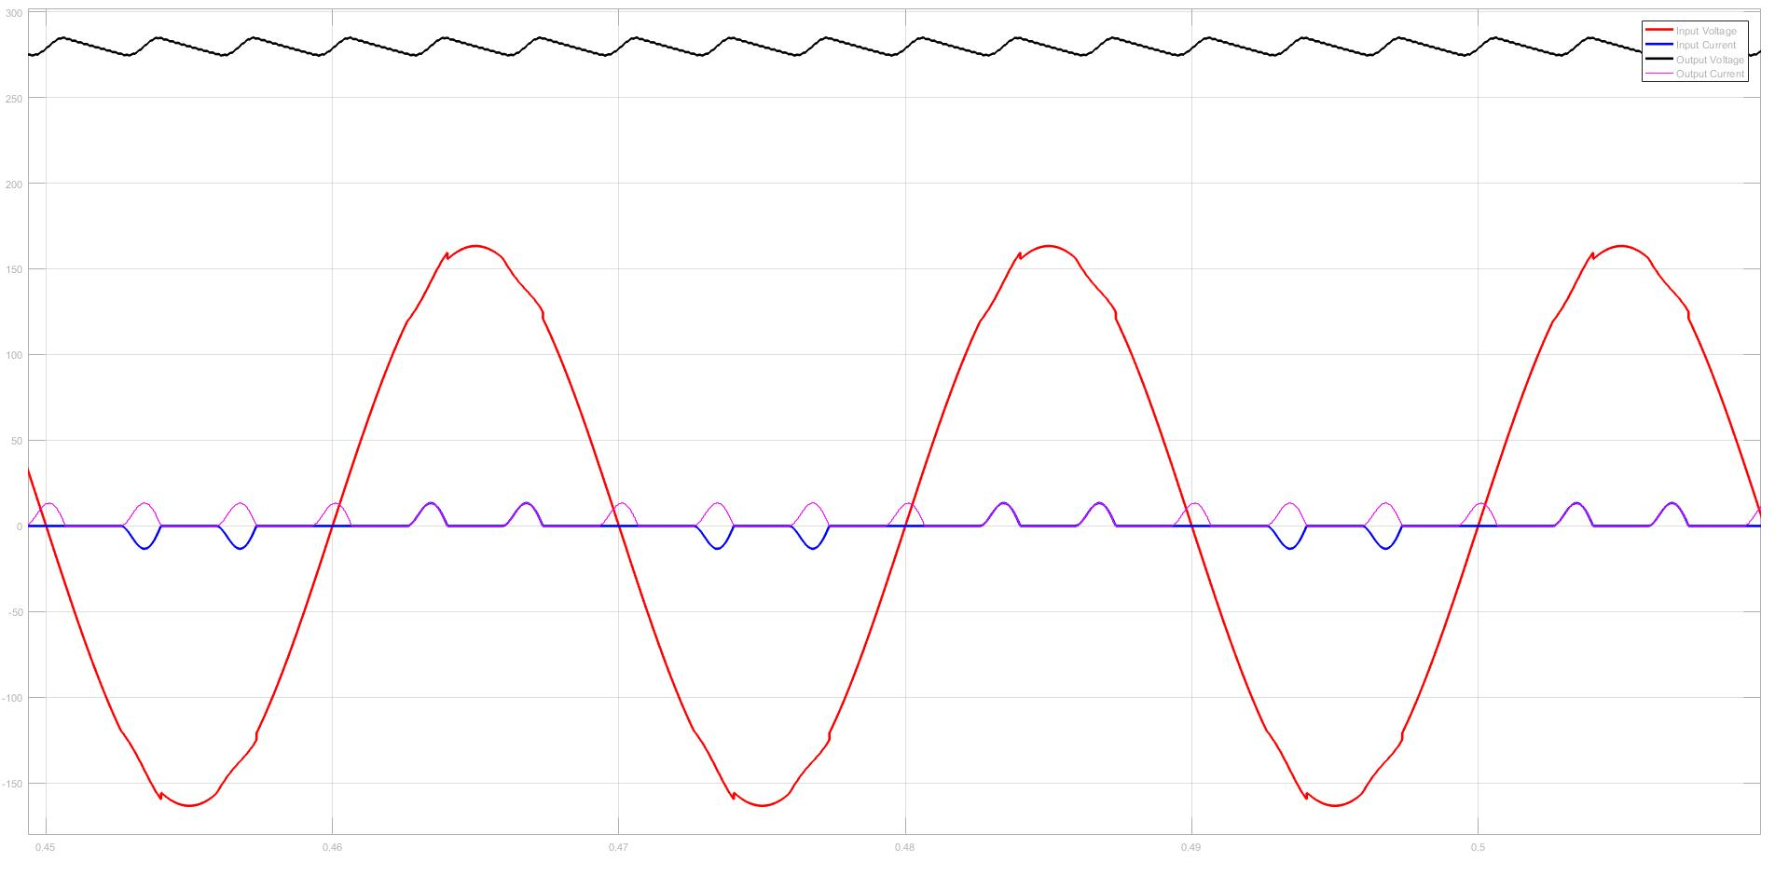

Figure 7: Input and Output Characteristic of the 3-Phase Diode Rectifier (50% Duty Cycle)

THD of the input current is equal to 149%.

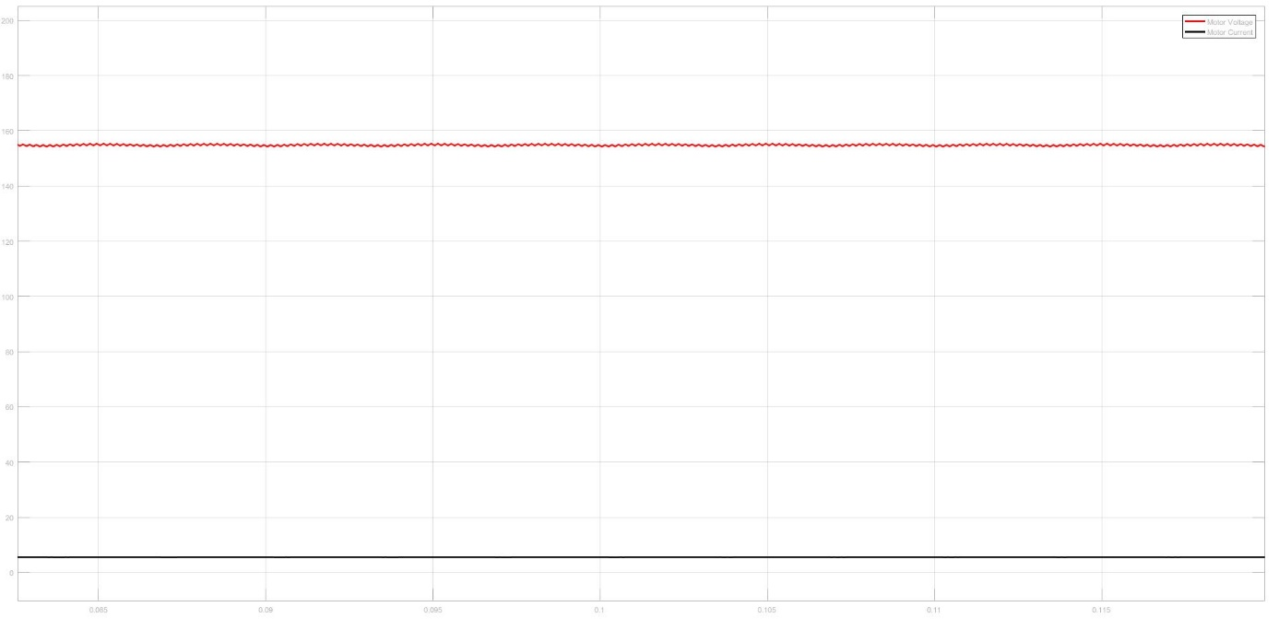

Figure 8: Output Characteristic of the Buck Converter (50% Duty Cycle)

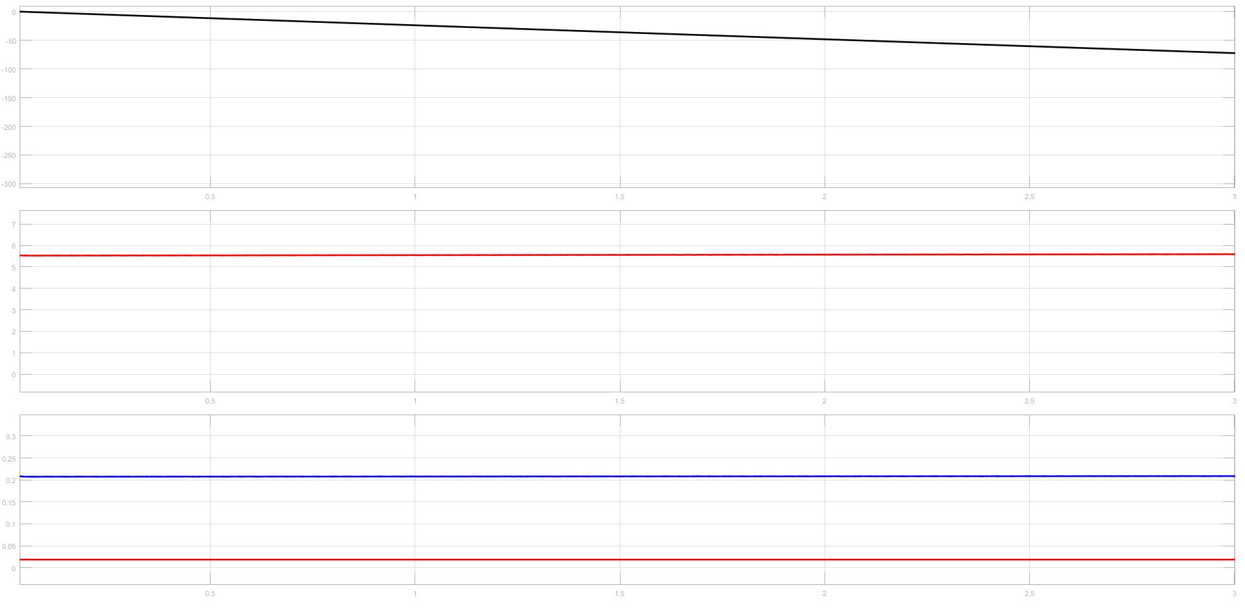

Figure 9: Motor Characteristic of the System (50% Duty Cycle)

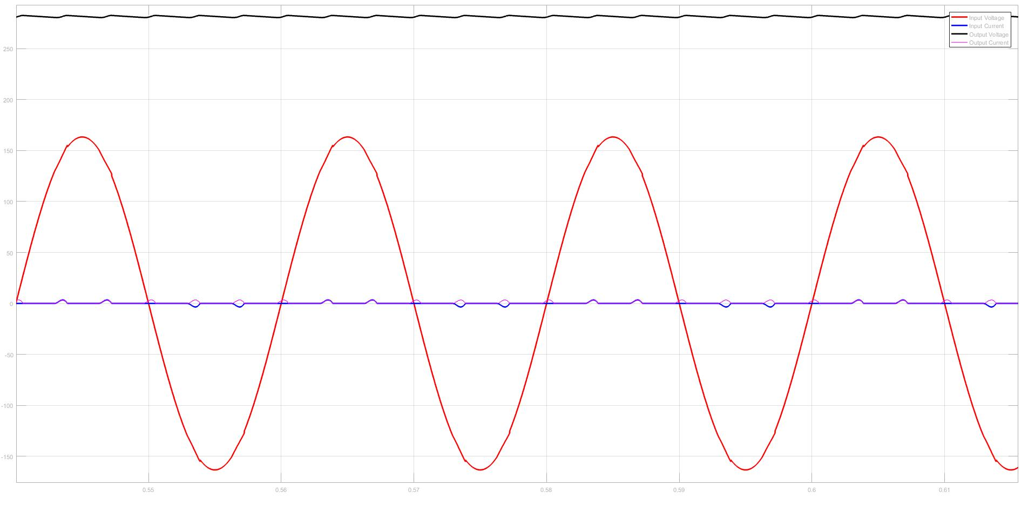

Figure 10: Input and Output Characteristic of the 3-Phase Diode Rectifier (15% Duty Cycle)

THD of the input current is equal to 191%.

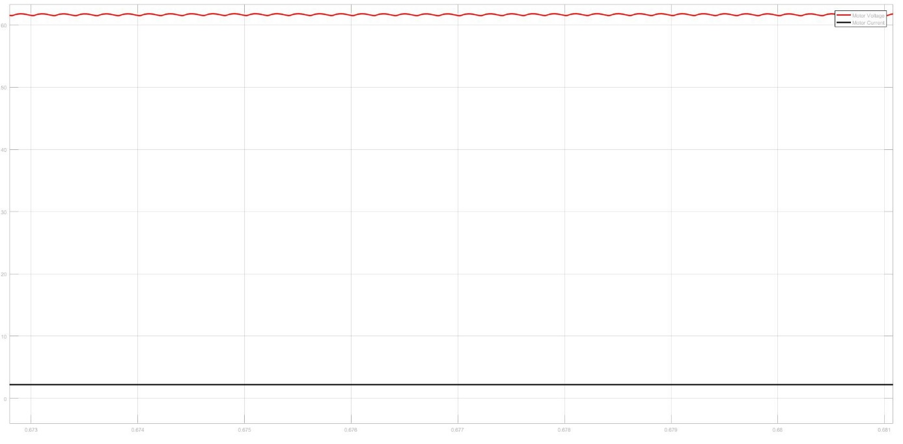

Figure 11: Output Characteristic of the Buck Converter (15% Duty Cycle)

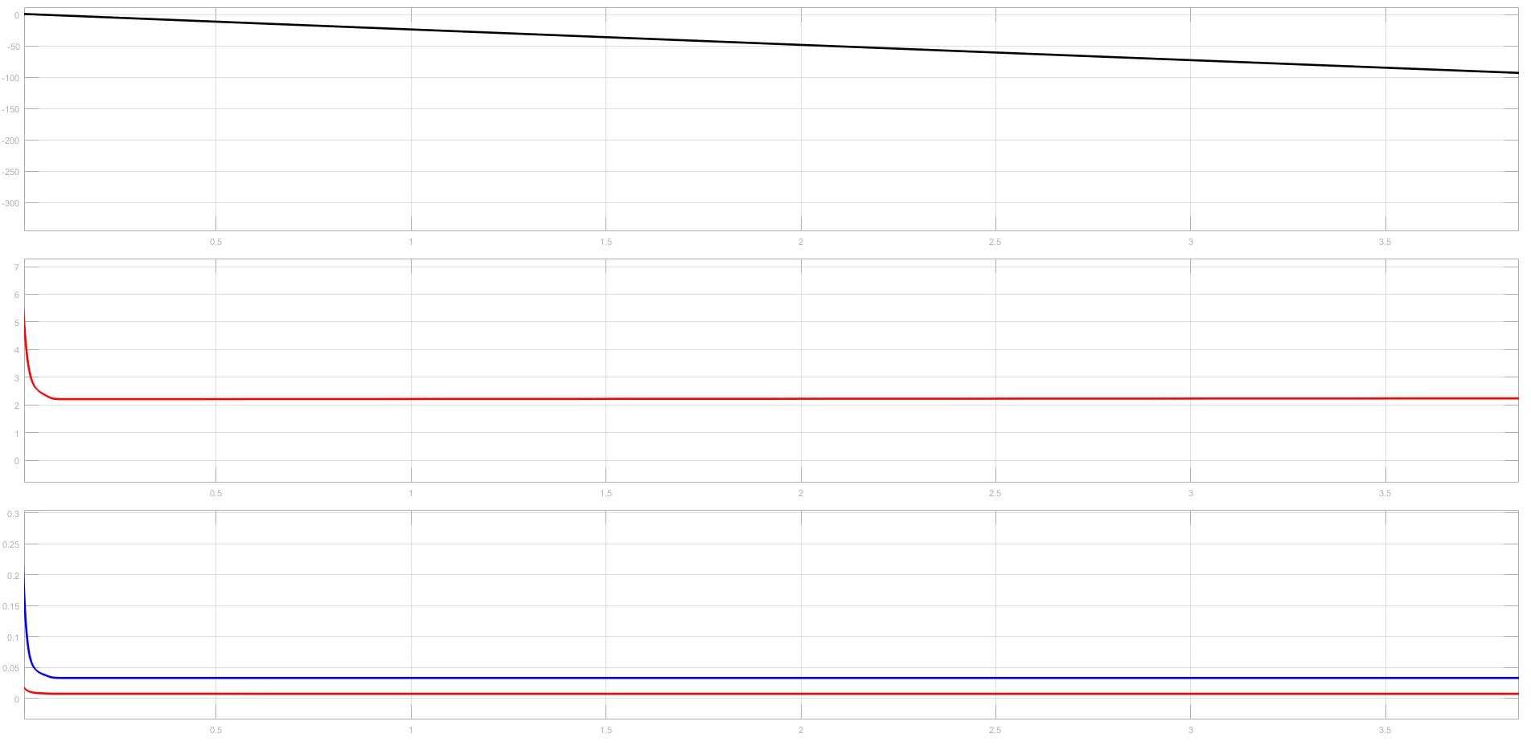

Figure 12: Motor Characteristic of the System (15% Duty Cycle)

According to these simulation results, characteristic of the selected topology was investigated. At the end, we decided that this topology totally suitable with our system. It is easy to use and it is efficient than other topologies. Also, some of the future problems are observed such as high starting current problem. Also PWM generation problem was considered and we decided that Arduino will be used for PWM generation and it will be connected to the system with an optocoupler circuit to isolate it from the driver circuit.

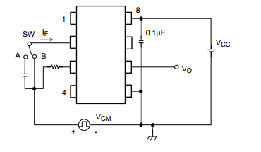

Figure 13: Schematic of the Optocoupler Circuit

5. Component Selection

Component selection is one of the most importing thing for hardware implementation. Since, components should be proper for the system and also their price performance ration should be in acceptable range. Also rating of the components should be selected proper since reliability of the system directly related with the rating of the components.

Firstly, components used in simulations were searched and their prices were listed. Then according to ratings, prices and accessibility one of them was selected.

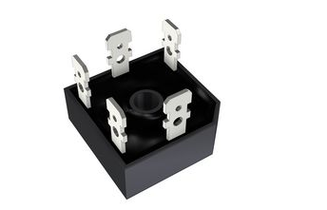

Figure 14: Selected Three-Phase Diode Rectifier (SBR3516)

Figure 14 shows the selected diode rectifier and Table 2 shows the some of the important data of the selected component.

Table 2: Some of the important characteristic of the SBR3516

|  |  |
| --- | --- |
| Peak Repetitive Voltage  Working Peak Reverse Voltage  DC Blocking Voltage | 1600V |
| Peak Non-Repetitive Reverse Voltage | 1700V |
| RMS Reverse Voltage | 1120V |
| Maximum Average Forward  Rectified Current @Tc = 60°C | 35A |
| Operating Temperature Range | -55°C to +150°C |
| Thermal Resistance Junction to Case at  DC Operation per Bridge | 1.16 k/W |
| Thermal Resistance Case to Heatsink Mounting  Surface, Smooth, Flat and Greased | 0.2k/W |

After that, switching element was selected. During this process, we searched two different component types which are IGBT and MOSFET. At the end we decided that MOSFET will be more reliable for our system. And according to similar criteria with component selecting we found a MOSFET which is proper for our system.

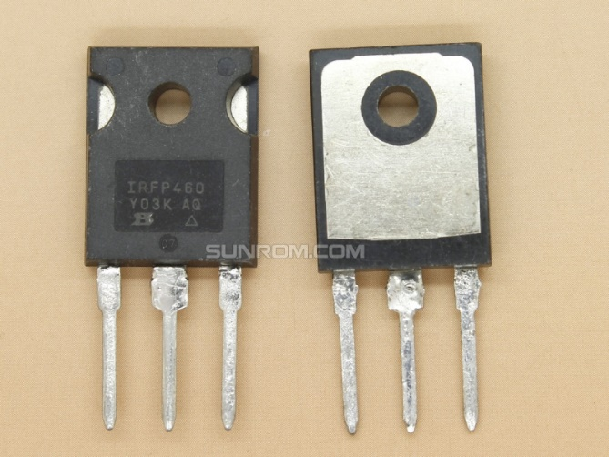

Figure 15: Selected MOSFET (IRFP460)

Figure 15 shows the selected MOSFET and Table 3 shows the important properties of the selected MOSFET.

Table 3: Some of the important properties of the IRFP460

|  |  |
| --- | --- |
| Drain-source voltage | 500V |
| Drain-gate voltage | 500V |
| Gate-source voltage | +-30V |
| Continuous drain current | 20A |
| Pulsed drain current | 80A |
| Total dissipation | 250W |
| Operating junction and storage temperature range | -55°C to 150°C |
| Thermal resistance junction to mounting base | 0.5K/W |
| Thermal resistance junction to ambient | 45K/W |
| Continuous source current (body diode) | 20A |

Then a diode was selected for the Buck Converter.

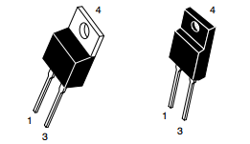

Figure 16: Selected Diode (U1560)

Average rectified forward current of this diode is equal to 15A and peak rectified forward current is equal to 30A.

After that, capacitors are selected for the DC link and low pass filter of the Buck Converter. Value of the capacitors are selected according to simulations and they were determined as 680uF. Then we started to examine proper capacitors for our system.

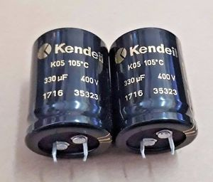

Figure 17: Selected Capacitors (Kendeil 400V 680uF)

Figure 17 shows the selected capacitors for our system.

After that we started to search for our last component which is inductor. Value of the inductor was determined according to simulation results. In the stores, we could not find proper inductor for our system so that we decided to make our inductor with a ferrite core and copper cable.

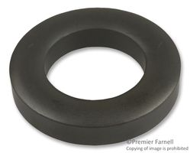

Figure 18: Ferrite core, Toroid 77

According to following equation,

$$\begin{aligned}L=\frac{μN^{2}A}{2πr} \#\left(1\right)\end{aligned}$$

A: cross-sectional area

r: toroid radius to centerline

Number of the turns calculated. According to simulations, value of the inductor determined as 1.3mH.

Also, according to thermal design calculations we bought proper heatsinks and a fan for our system.

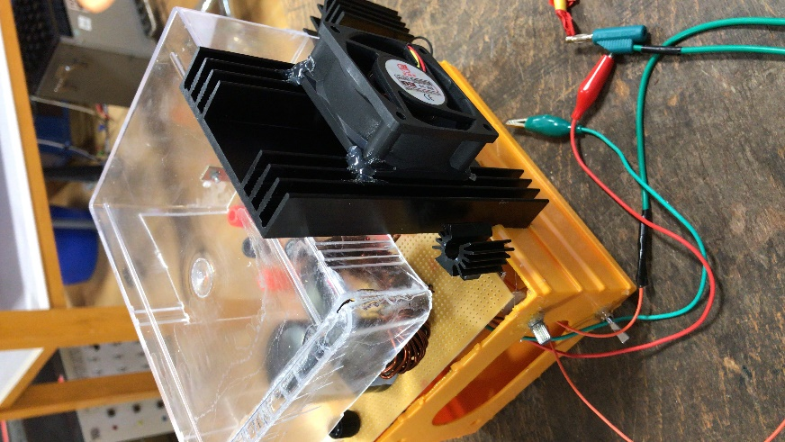

Figure 19: Used Heatsink and Fan

6. Test Results

6.1. Rectifier Test

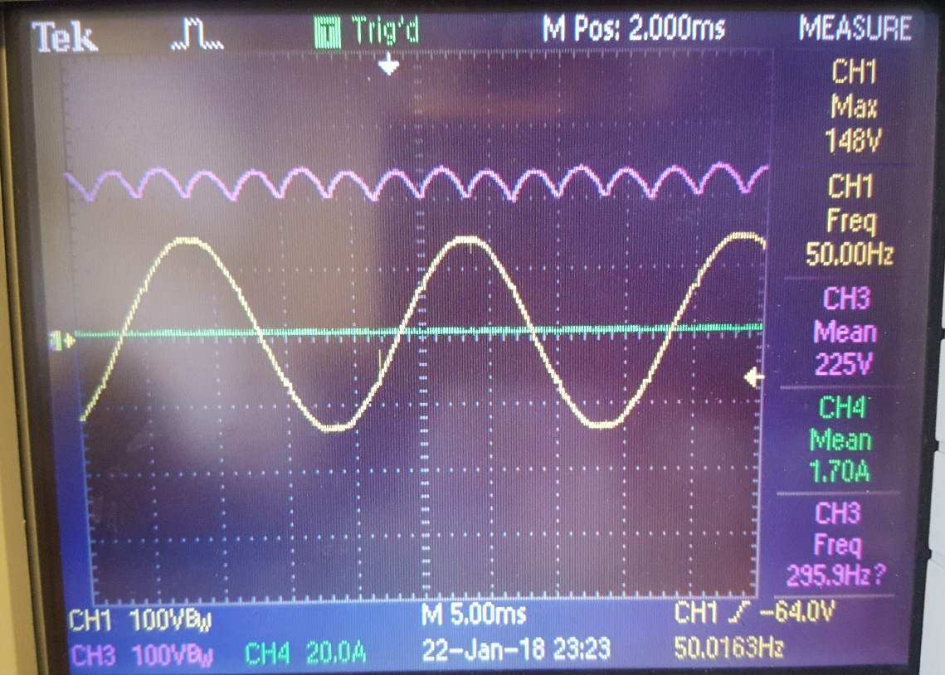

Figure 20: Input voltage waveform and 3-phase rectifier output voltage waveform

V­o = 1.35×VL-L

Using 3-phase bridge rectifier, we got a 6-pulse output voltage as shown above

6.2. Pulse Width Modulation using Arduino

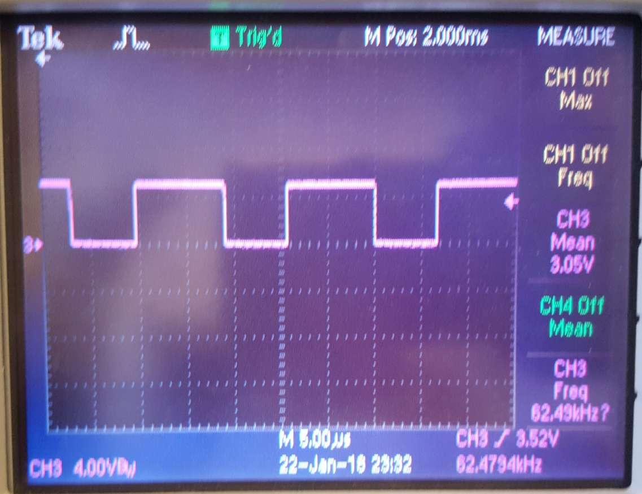

Figure 21: Arduino PWM output

Duty cycle of PWM was varied using a potentiometer connected to A0, 5V and GND pins to Arduino, and output taken from PWM-5 pin

6.3. R-Load Test of Buck Converter

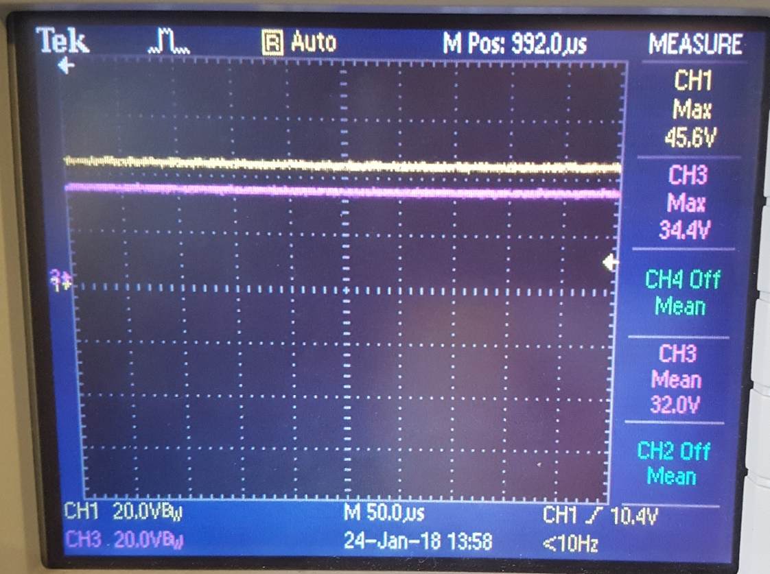

Figure 22: Output voltage waveform at 75% duty cycle

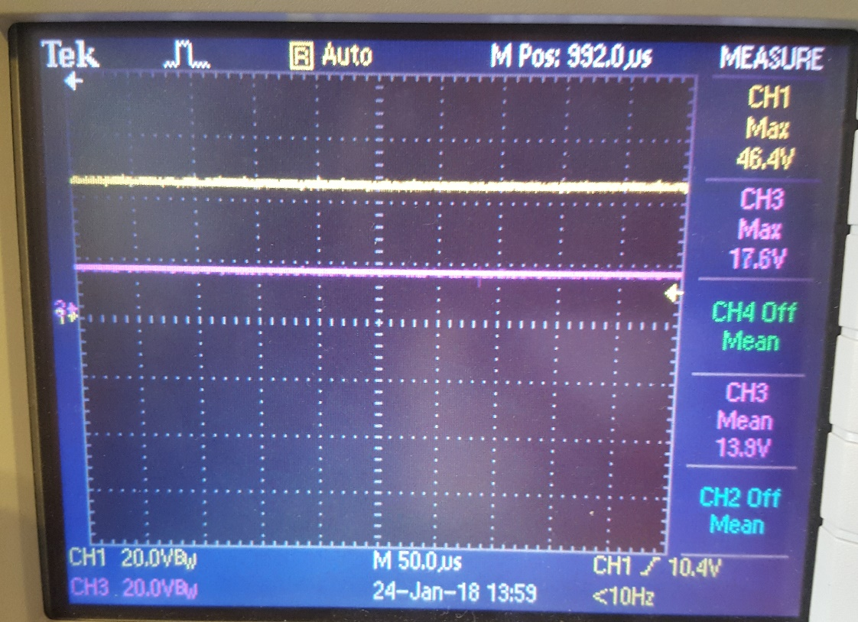

Figure 23: Output voltage waveform at 37% duty cycle

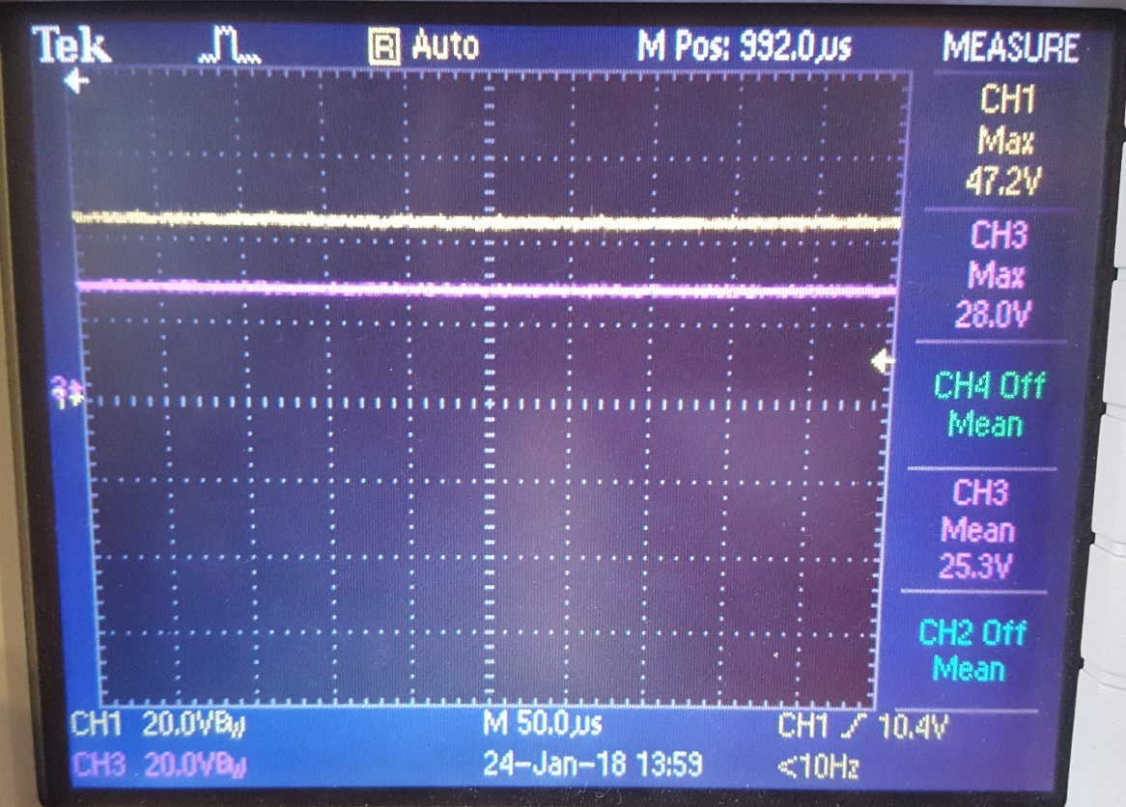

Figure 24: Output voltage waveform at 59% duty cycle.

Vo= D × Vd (D- duty cycle, Vd- Rectifier output voltage)

The output voltage was successfully varied in a controlled manner without any distortion, however current waveform had a significant distortion with high THD value

6.4. RL-Load Test of Buck Converter

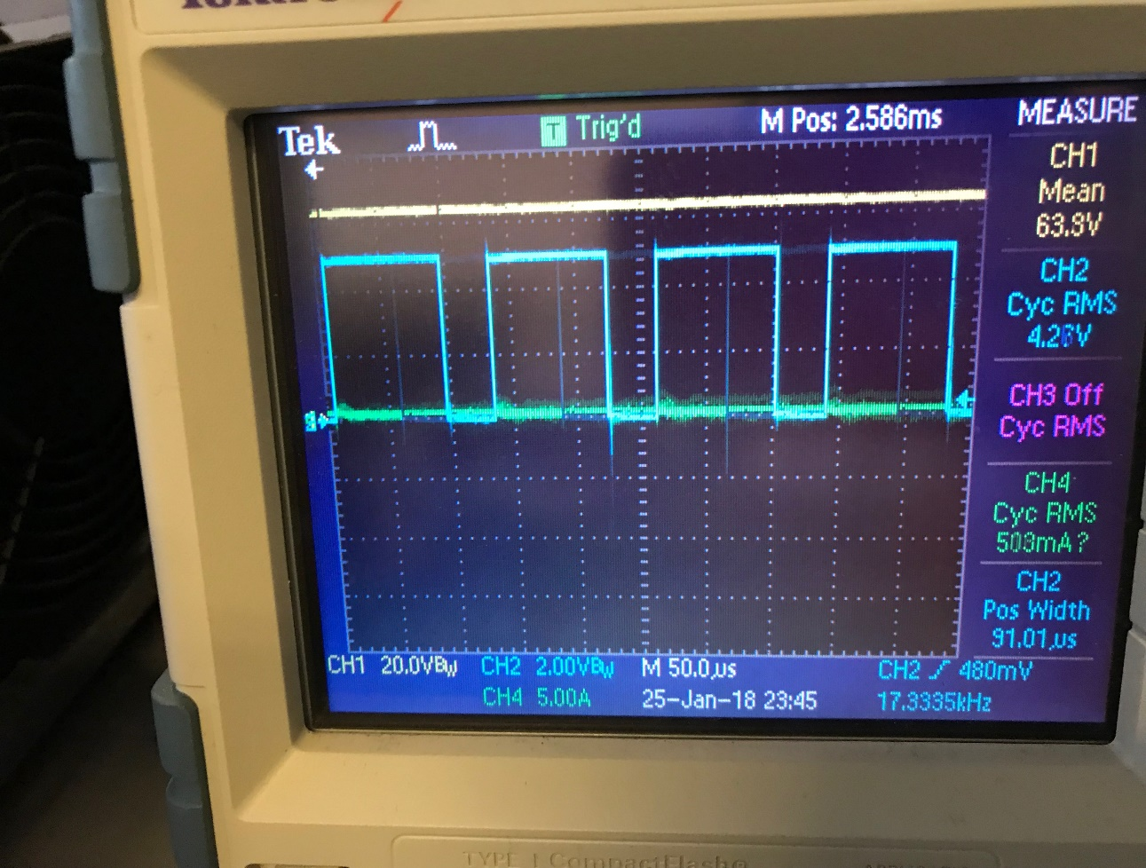

Figure 25: Output voltage waveform at 85% duty cycle

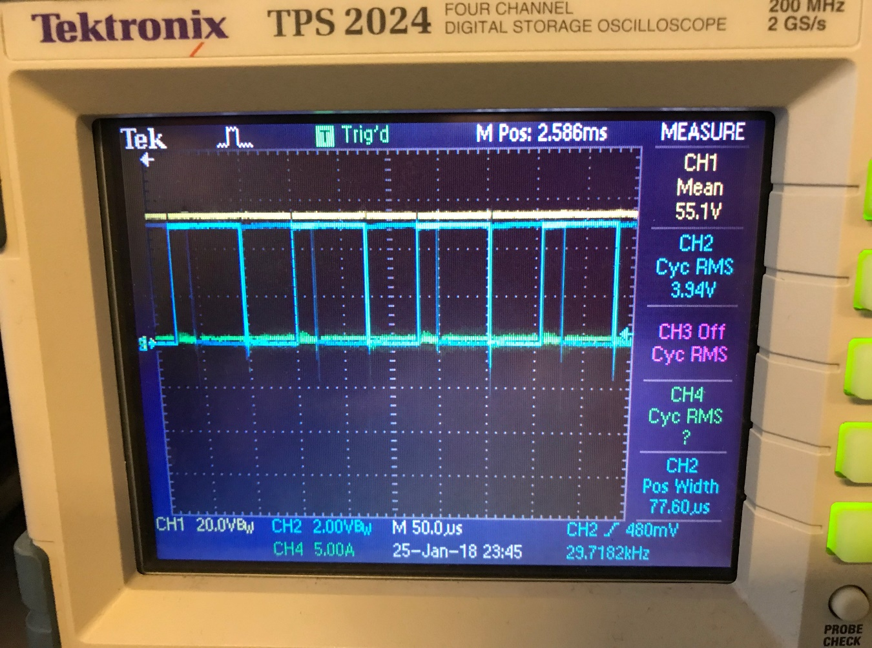

Figure 26: Output voltage waveform at 50% duty cycle

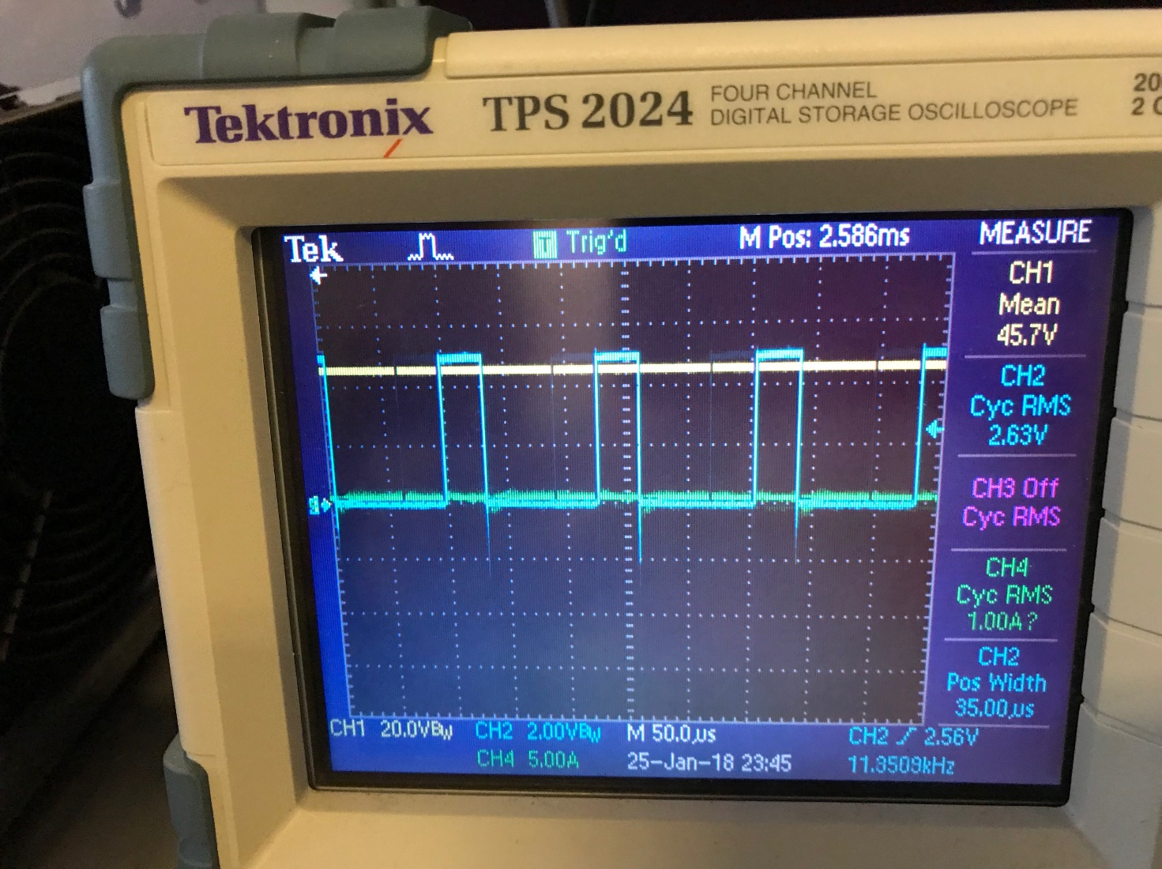

Figure 27: Output voltage waveform at 15% duty cycle

RL-Load test is the preliminary step before going to motor drive test, and results that were obtained turned out to be encouraging. After getting this results, we performed the motor drive operation successfully

7. Thermal Design

Every component inside the system should be considered as a heat source. Therefore, to prevent component which were used in the system, thermal design was done for the system. In our system, especially, thermal design was done for the three phase diode rectifier and the switching element which is MOSFET. Since, they produce more heat than other element and the temperature is critical for them. To prevent MOSFET from the increasing heat problem heatsink and fan were used.

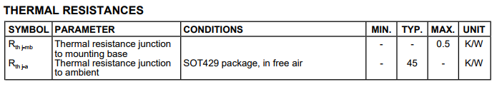

Figure 28: Thermal Characteristic of the MOSFET (model: IRFP460)

Thermal characteristic of the heatsink were calculated according to maximum current and voltage levels. Expected maximum current flow through MOSFET is equal to 12A under full-load condition. And also calculations are considered at full conduction period.

$$I_{max}=12A$$

$$V_{DS}=0.27Ω*I_{max}=3.24V$$

$$P_{C}=I_{max}*V_{DS}= 38.88W$$

$$T_{change}=P_{C}*\left(R_{th j-mb}+R_{th j-a}\right)=1769.04C^{0}$$

According to calculations, while system working under full-load, temperature of the MOSFET will increased 1769.04degree from the room temperature and it will burn suddenly.

We decided that under full load, maximum temperature of the MOSFET should remain at most 80degree. So that heat capacity of the heatsink should be equal to,

$$R_{heatsink}=\frac{80-25}{12*3.24}=1.41\frac{K}{W}$$

Then, we searched a heat sing that provide this characteristic.

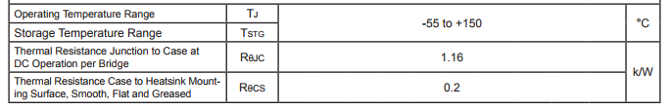

Figure 29: Thermal Characteristic of the Diode Rectifier (model: SBR3516)

Same procedure applied for the calculation of the diode rectifier heatsink. Maximum current flow through on diode rectifier is nearly equal to 5.3A at full-load.

$$I_{max}=5.3A$$

According to datasheet of the diode rectifier, maximum voltage drops per element at 12.5A/17.5A peak is equal to 1.2V. At the same time, two of the element will be open so that, voltage drop will equal to 2.4V.

$$V_{drop}=2.4V$$

$$P_{C}=I_{max}*V_{DS}= 12.72W$$

$$T_{change}=P_{C}*\left(R_{th j-mb}+R_{th j-a}\right)=17.3C^{0}$$

According to calculations, we do not need any heatsink for the diode rectifier but stay in safe region we bought a heatsink for the three phase diode rectifier.

8. Cost Analysis

Table 4: Costs of components.

|  |  |  |  |
| --- | --- | --- | --- |
| Item | Cost (per unit) TL | Quantity | Total |
| Capacitor (680µF, 400V) | 18 | 2 | 36 |
| Inductor coil (20A) | 5 | 2(meters) | 10 |
| MOSFET | 8 | 2 | 16 |
| Heatsink for Mosfet | 13 | 1 | 13 |
| Bridge Rectifier (35A) | 15 | 1 | 15 |
| Heatsink for Rectifier | 5 | 1 | 5 |
| Freewheeling diode (20A) | 5 | 2 | 10 |
| Heatsink for FW Diode | 2 | 1 | 2 |
| Optocoupler | 3 | 2 | 6 |
| Pertinax | 5 | 1 | 5 |
| Cable | 3 | 2(meters) | 6 |
| Arduino | 35 | 1 | 35 |
| **OVERALL** |  |  | **159** |

Table 5: Labor force costs.

|  |  |  |  |
| --- | --- | --- | --- |
| Project stages | Working hours | | |
| Özgür | Talgat | M.Emin |
| Conceptual design | 3 | 2 | 3 |
| Component purchase | 2 | 2 | 2 |
| Build / Test | 28 | 30 | 27 |
| Demo / Report | 4 | 3 | 5 |
| TOTAL | 37 | 37 | 37 |
| Hour = 30 TL | 1110 | 1110 | 1110 |

Total project cost - 3489 TL

9. Conclusions

In conclusion, during our research we have successfully accomplished making the AC to DC Motor Drive. We started with conceptual design by selecting appropriate topology that would be easy to implement and would be operating in a stable manner. We performed simulations to verify proper operation and then selected components. In the laboratory we built our prototype, tested it and took measurements. After testing our circuit we then passed on to motor test. Getting the results flawlessly, we enclosed it into box to give industrial design shape. On the demo day, our model worked well, the speed was controlled successfully.

We gained necessary practical experience during hardware project implementation process that also supported our theoretical knowledge obtained in class. Teamwork and time coordination also proved to be very important.